Laser Cutter Manual

Oxford Hackspace

Version 1.0
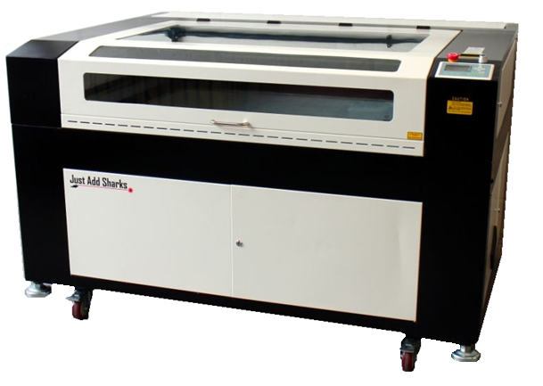


Introduction
The Laser cutter is a fragile piece of equipment.
Humans are also fragile when interacting with dangerous equipment.
As such, guidelines for safe operation are below.
Knocking the machine can throw the optics out of alignment which will make the machine inoperable until maintenance is performed.
As such a key behaviour when operating or being in the vicinity of the Laser Cutter is to be aware of your actions, operate calmly and smoothly and at a restrained pace to avoid the aforementioned possibility.
Be especially careful when inserting or removing material from the cutter as hitting the cutting head will almost always affect alignment.
The laser cutter has a window which allows you to view the cutter head as it operates, when viewing it cutting you can see visible light produced when the laser interacts with the medium it is cutting.
Please note that when a bright light is being produced, do not stare at the beam for prolonged periods as bright light could damage your eyes.
However should you watch the light produced from cutting, the likelihood of damage having occurred is minimal as it is primarily visible light, this is simply a caution.
The laser cutter interlock only stops the laser beam from operating with the lid open, the machine will still carry out manoeuvres with the lid open.
Never manually move the head as you risk damaging the machine or effecting the optical alignment.
Try not to leave the machine switched on with the lid open except when performing maintenance (reserved for trained individuals ONLY!) or when setting the bed height.
When going to insert, remove or interact within the machine, press ESC then Datum to home the cutting head.
When cutting any materials, the cutter produces fumes and particulates, these are sucked out of the machine and into the 4 stage filter.
Before starting any operation, make sure the extraction fan is powered on (black plug under the filter must be plugged in to turn on fan).
When finishing any operation, do not open the lid for at least 30 seconds, then ensure the fan remains of for at least 10 minutes after the last job is complete.
As a general guide:
4mm Acrylic is cut at 100% power, 4 mms⁻¹ speed
2mm Acrylic is cut at 100% power, 10 mms⁻¹ speed
4mm Plywood is cut at 100% power, 5 mms⁻¹ speed
Paper is cut at 30% power, 200 mms⁻¹ speed
Do not use any materials in the laser cutter unless they are approved on the materials whitelist. This can be found, along with further information about materials and cutting speeds on the OxHack wiki: http://wiki.oxhack.org/wiki/Laser_Cutter_Materials_List

Safety & Permissions

Modifications
You are NOT allowed to perform any modifications or improvements to the machine, should you be found to have modified the machine in any way without permission from a technician, you will be permanently banned from using the machine and fined for damages.

Tasks & Maintenance
You are required to perform some tasks and maintenance when the machine is in use, these include:
Notifying the keyholder that the machine will be in use.
Cleaning the machine of debris before use.
Cleaning the machine of debris after use.
Logging your usage.
Paying for your usage.
Should these tasks not be completed at the time of usage, there my be repercussions as you may have risked damaging property, yourself or others.

Procedure
Should the machine behave unexpectedly or should anything unexpected happen, immediately shut down the machine by pressing the large red emergency button on the front panel, notify a keyholder of the issue.

Fire
Using lasers to cut flammable materials carries an inherent risk of fire. For this reason, the following rules must always be followed:
- Be aware of the location of the nearest fire extinguisher. Currently, this is just outside the door of the laser cutter room. Only use CO2 extinguishers on the laser cutter.
- Never leave the laser cutter unattended while cutting.
- If you see flames on the material you are cutting, watch for a few seconds to see if they self-extinguish. If not, fetch the fire extinguisher.
- Record any sustained fire incidents in the Laser Cutter Fire Incident Log. This will help us improve our safety policies.
Most importantly, do not put yourself at risk. If you are unable to deal with a fire, sound the alarm and leave the building.

Ventilation
The ventilation system carries harmful gas and particulates away from the cutter and filters them, it is important the extraction always be operating when the cutter is powered on.
Should the ventilation fail immediately pause the cutter and do not start any cutting then go and contact a keyholder.

Operating Steps.
(AT ANY POINT SHOULD THE CUTTER OPERATE OUTSIDE EXPECTED PARAMETERS, HIT THE RED EMERGENCY STOP BUTTON SITUATED NEXT TO THE POWER SWITCH KEY.)
- Open the Lasercut 5.3 software. (blue icon on desktop) and follow the instructions in the ‘Software’ section of this manual to set up the cut.
- Check the air pipe from the 4 stage filter to the cutter is connected.
- Check the blue USB cable from the laser cutter is plugged into the laptop.
- Check the white USB dongle is also plugged into the laptop.
- Insert the material to be cut into the cutting bed.
- Place your key fob on the sensor pad, the power will then switch on to the cutter, extractor, air pump and water cooler. You must leave your fob in place for the cutter to operate, if you remove it from the pad, you have 30 seconds before the power shuts off. Should you need to temporarily leave the room, pause the cutter and leave your fob.
- Check the chiller unit lights are on and a temperature is being displayed.
- Check that the laser head has homed to the top right corner of the machine.
- Download the file to the laser cutter by selecting the button in the bottom left entitled “downLoad”.
- A menu will pop up, select Delete All then select download current. (should the menu not appear when you select “downLoad”, unplug and replug in the blue USB cable and try again, if this does not work, restart Lasercut and power cycle the cutter).
- Upon downloading to the laser cutter, go to the laser cutter button pad. (press ESC twice to enable manual control of the cutting head).
- Move the cutting head to the top right of the material being cut and press test.
(when you press test, the cutter will trace the maximum rectangular outline of the object to be cut, if this matches your provided material to cut, proceed)
- Whilst using the bed height alignment tool, press Z to enter bed adjust mode, raise or lower the bed so that the bottom of the lip on the tool touchers the lip of the laser head and the bottom of the tool touches your material.
(Insert image of tool held in place over cutting head with arrow markers pointing out relevant points)
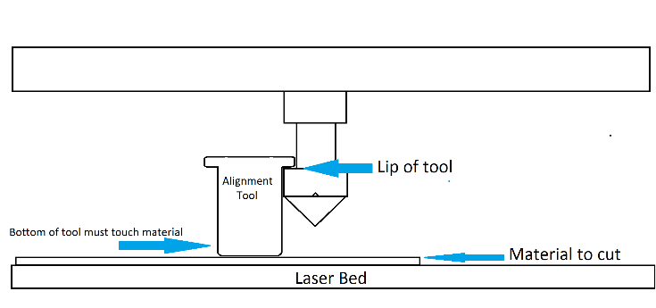
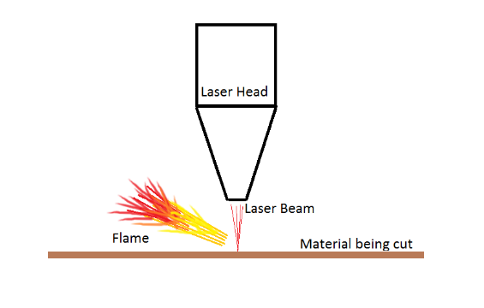
- With the cutter set up correctly, feel the nose of the cutting head to make sure it is clear of debris then close the lid and press start (if there is debris, it should be very easy to remove as it will most likely be carbon dust built up).
- Observe the laser cutter as it runs and ensure the material being cut does not sustain fire (ensure it does not continue to burn when the laser beam has moved on, fire at the point of the cut moving with the cut is a typical occurrence for certain materials and should be allowed to continue).
- Observe the flow of smoke from the cutting head, it should be flowing quickly, pulled to the rear of the machine and should not be building up, if it does build up and does not appear to be flowing stop the machine and check the pipes of the extraction system are still connected throughout the system.
Make sure you do not knock the cutter at any point during its cutting process as this may move the material and throw off alignment ruining your work.

- When the machine completes the cut it will beep and move the cutting head back to the start position, at this point carefully lift the lid of the cutter
- Place one hand very smoothly but firmly on the material so as not to move it or the cutting bed and with the other hand gently try pick up a part of the cut material, if you can remove a cut out or you can see the cut went through the whole material and was successful then remove your work otherwise close the lid gently and run the same cut again (if you were careful not to move your work, it should cut over the previous cuts perfectly).
- pickup any small waste that is produced from the process and has been left on the cutting bed, close the lid of the cutter power it off by removing your key fob.
- leave the extractor running for approximately 10 minutes them power it off.
- Fill out the log sheet. (It is very important that you fill out the laser cutter log sheet, if you do not log your use right after cutting, you risk a ban from using the cutter)

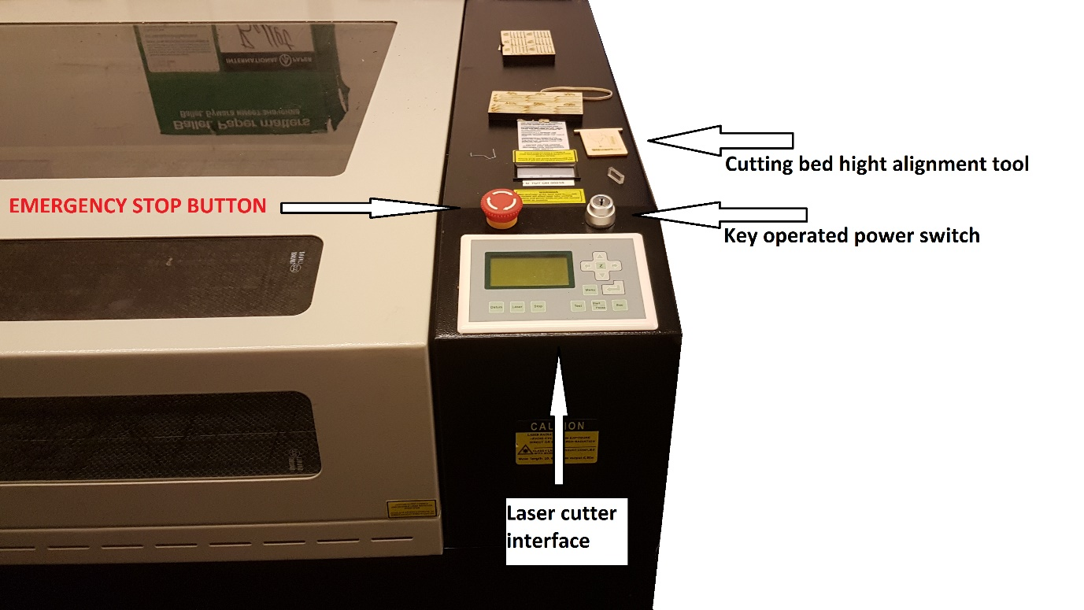
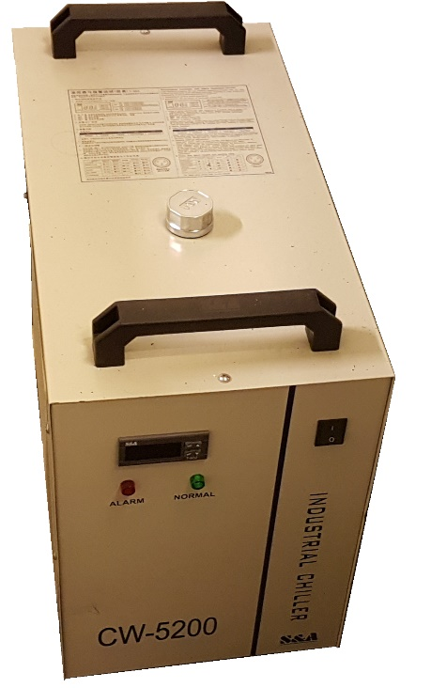
This is the chiller box that cools the laser cutter tube, it is vital that this be powered on if the laser is operational.
It has a display on the front that indicates the current internal temperature of the water reservoir, this tends to hover around 28c but should never go over 40.
This is not something you generally need to monitor but do check it occasionally.

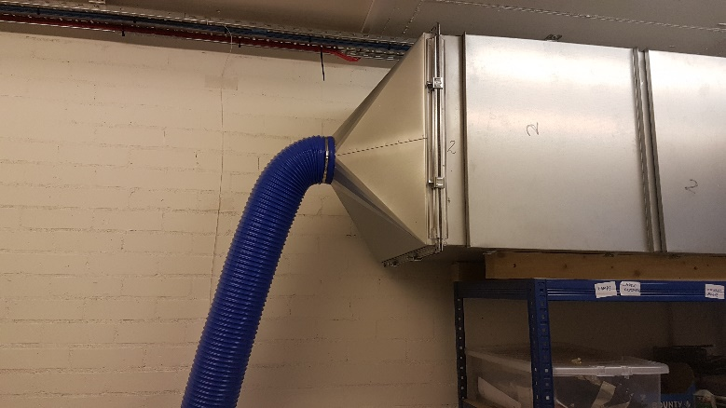
Front of filtration unit.
The hose is mounted with a clamp ring to the head of the unit.

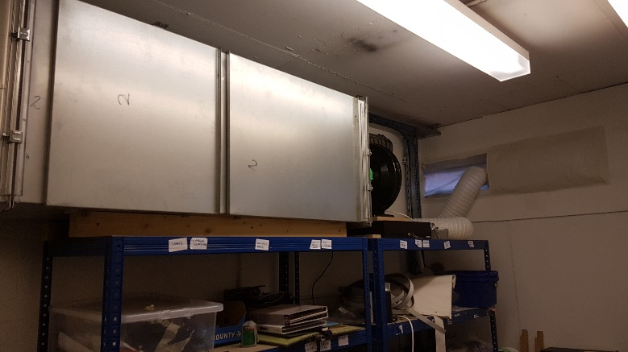

Rear of filtration unit

Software (how to set up a cut)
Start Lasercut 5.3 from the icon on the desktop.
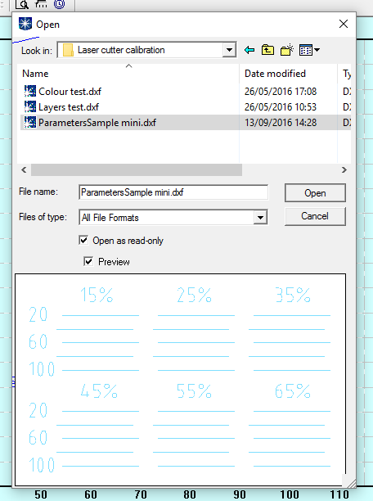
Go to File and click import.
Locate your file and double tap it to open.
If you single tap the file, a preview window will show it however the software is buggy and can freeze so it is best to only double click on your file.
Highlight the entire drawing area by using key command Control + A, select tools then select unite lines and apply. (Generally you can leave the line spacing option at its default value)
Click in a blank area and drag a box around any lines to highlight them, they will turn blue to show they have been selected.
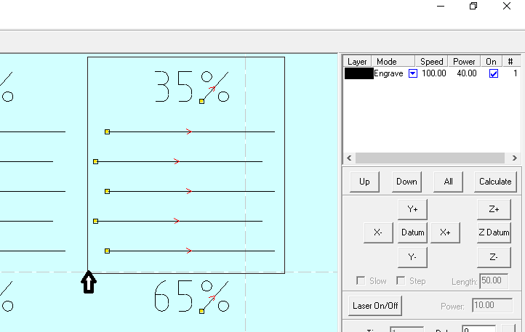

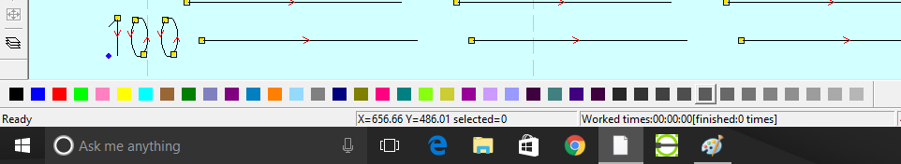
Choose a colour from the bar at the bottom of the screen to change the selected lines colour.

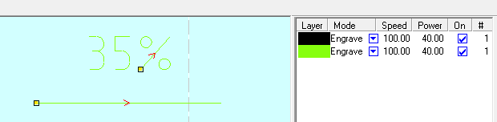
When you have any lines on screen, they will be represented by their colour on the right hand side, for every colour you will have a settings option
Double click on one of the colours settings to modify them, you can change power or speed.
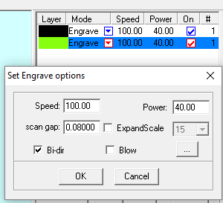
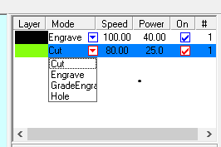
Or click on the drop down arrow to change from the engrave operation to cut.

